**Introduction to Statistical Computing**

**MATH1322**

**Assignment-1**

**Analysis of Survey Results of Older Australians**

**By- Piyush Bhatt**

**S3652293**

**Table of Contents**

Introduction 3

Methods 3

Results 3

Conclusion 7

References 8

**Introduction**

The dataset contains survey results from Older Australians, on their preparation for retirement. There are 1524 older Australians aged around 60 years and plus, and the survey tries to find out different aspects of financial preparation for their retirement.

Survey has various question like age, marital status, area you live in till the question related to mortgage of house, annual income etc.

The objective of the survey is to find out how well prepared are the Older Australian for their retirement.

**Methods**

The survey was conducted, and the results were formatted in the Microsoft Excel sheet. Microsoft Excel is the tool used to analyse the results of the survey. Further the Pivot charts and other charts/graphs were used to answer various questions.

Formula like “COUNTIFS” was used to answer conditional questions.

**Results**

1. Produce a Pivot Table to compare the gender of respondents in each age group. Show the values as a percentage of the total respondents.

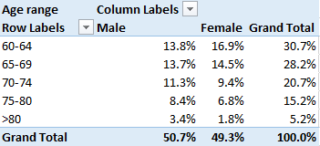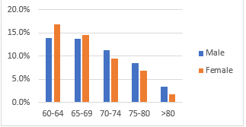

Around 60% of respondents fall under 60-69 years of age followed by 70-80 years of age bracket, and only 5% respondents are over the age of 80 years.

Also, the number of males 50.7% and females 49.3% respondents are almost equal.

1. Calculate the time taken to complete the survey for each respondent.

The time taken calculated by difference between the start date (Survey start date) and the date (Survey complete date). The median which is calculated comes out to be 18 Minutes and 51 seconds.

Formula = MEDIAN(C3:C1526)

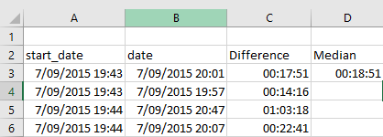

1. Produce a Pivot Chart to show the primary source of income for all the respondents that are not yet retired. Show the number of respondents based on their employment classification.

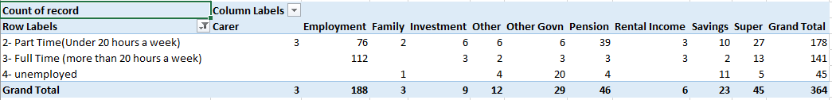

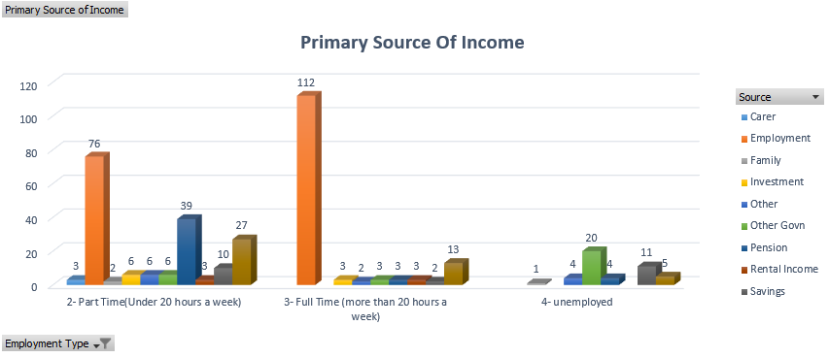

From the above pivot table and the chart, for part time employed respondents the pension is one major source of income followed by super and for the respondents who are working full time is employment itself and then followed by super.

Respondents who are unemployed have the other Government schemes as their major source of income followed by their savings.

1. Using a single Excel formula find the number of respondents who are 65 or over that still owe more than $50,000 on their mortgage and have an annual income of $100,000 or less.

The ‘COUNTIFS’ formula used to perform the calculation:

=COUNTIFS(data!D:D,">=65",data!AL:AL,">=2",data!AL:AL,"<8",data!AI:AI,"<=4")

Answer is 56.

1. Include any other relevant summary information from this data source to assist you to make a statement regarding how financially prepared Older Australians are for retirement.
2. What type of property they live in?

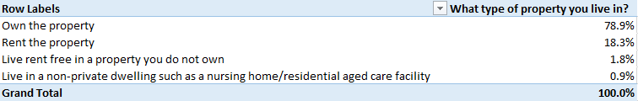

Approx. 79% of the respondents own the property and 18% rent the property they live in.

1. Do they have any other source of income?

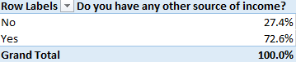

It can be said that around 72% of the respondents have other source of income apart from their primary source of income.

1. Do they currently have a mortgage on their own home?

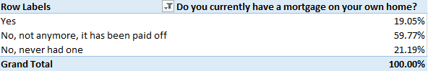 About 60% of the respondents do not have mortgage on their own home. And only 19% have a mortgage on their own home.

1. Did they pay off their mortgage before or after they retired?

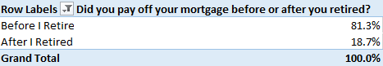

About 81% of the respondents payed off their mortgage before they retired and 19% did not.

1. When it comes to money and finances generally would you regard yourself as?

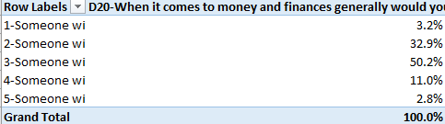

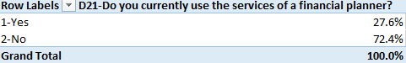

About 73% respondent does not consult a financial planner as they posses good knowledge about finances.

**Conclusion**

After observing the above survey results and from the above 5 points it can be concluded that majority of the Old Australians are well prepared for the retirement as most of them own their own house, does not have or have paid off their mortgage and those who have 60% of them are expecting to pay off before their retirement.

Also, it can be concluded that the major source of income is full time employment and part time employment followed by its Super.

Older Australians possess good knowledge about the house related financial products and don't consult a financial planner or guide as stated by more than 80% respondents, which is why they have planned their housing need well. About 80% of respondents own a house and have paid their mortgage before retiring.

**References**

1. RMIT Canvas- Sample Report and Dataset file

<https://rmit.instructure.com/courses/52567/assignments/361797>

1. Data Source- Housing Decisions of Older Australians

<https://data.gov.au/dataset/ds-dga-ba721636-6744-460e-ba05-34316582a337/details?q=Housing%20Decisions%20of%20Older%20Australians>